Court Service

Training Environment Guide



Reference: Training Environment Guide

Version 0.1

12 May 2003



Statement of Confidentiality

This document is proprietary to Electronic Data Systems Limited, (EDS), its parent company Electronic Data Systems Corporation and any of that corporation’s subsidiaries. The document is supplied in confidence and except for the purpose of evaluation by the Department should not be disclosed or otherwise revealed to outside parties without the prior written consent of EDS.
These limitations are commercial in nature and are not in any way intended to restrict continuing business between the Department and EDS.
Copyright

Copyright in this work is vested in EDS and the document is issued in confidence for the purpose only for which it is supplied. It must not be reproduced in whole or in part or used for tendering or manufacturing purposes except under an agreement or with the consent in writing of EDS and then only on the condition that this notice is included in any such reproduction. No information as to the contents or subject matter of this document or any part thereof arising directly or indirectly there from shall be given orally or in writing or communicated in any manner whatsoever to any third party being an individual firm or company or any employee thereof without the prior consent in writing of EDS.

-EDS is a registered mark and the EDS logo is a trademark of Electronic Data Systems Corporation.
-EDS is an equal opportunity employer and values the diversity of its people.

Copyright ©2002 Electronic Data Systems Corporation. All rights reserved.
DOCUMENT AUTHORISATION

DOCUMENT TITLE | Training Environment Guide
DOCUMENT REFERENCE | ISSUE | DATE
Training Environment Guide | 0.1 | 12 May 2003

 | NAME | SIGNATURE | DATE
AUTHORS | Alex Brown | ELECTRONIC | 08/05/2003
REVIEWERS

AUTHORISED BY

Change Control

Version | Status | Description of Changes | Date
0.1 | Alex Brown | Initial draft | 08/05/2003

CONTENTS PAGE
1 Introduction 7
1.1 Purpose 7
1.2 Scope 7
1.3 Who should read this document 7
1.4 How to Use this Guide 7
2 Oracle 7
2.1 Installing Oracle 9.1 Client 9.2.0.1.0 7
2.2 TNSNAMES.ORA 14
2.3 CLASSES12.ZIP Error! Bookmark not defined.
3 SYSTEM DSN 14
4 Training Application for running the scripts 18

Introduction

Purpose
This document is designed to ensure that the process of setting up the trainer’s pc has a common environment. It should demonstrate the XHIBIT project’s commitment to quality, repeatable processes and maintain the high client confidence in project deliverables.

Scope
This document is not intended to replace existing user guides provided by vendors. It is a short summary of XHIBIT project specific issues. Check out the links under Further Information sections for product documentation.

This document is not intended as a training document per se, rather to should guide anyone wishing to install the training environment on how to quickly, consistently and effectively configure his or her training environment.

All guidance has exceptions that were not considered at the time of writing. If you discover error, omissions or scenarios where mandatory guidance cannot being adhered to please feed this back to the document owner.

Who should read this document
Anyone who has to configure the trainer’s pc.

How to Use this Guide
For software installation and configuration this guide can initially be read sequentially.

Oracle

Installing Oracle 9.1 Client 9.2.0.1.0
Run from CD or disk and install Oracle Client as shown below:

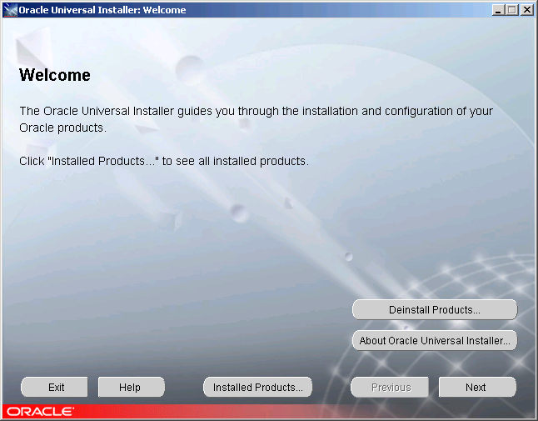

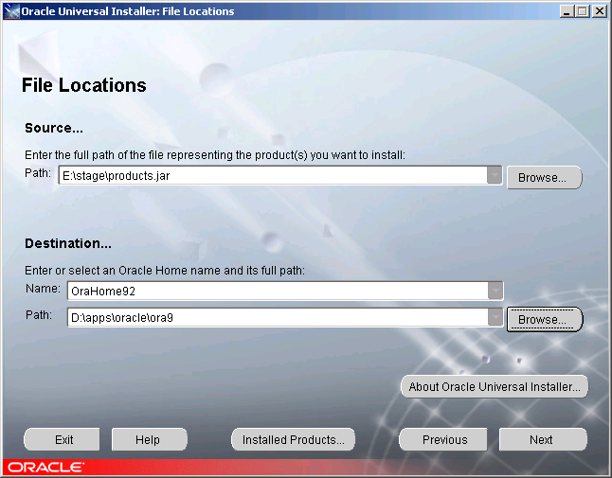

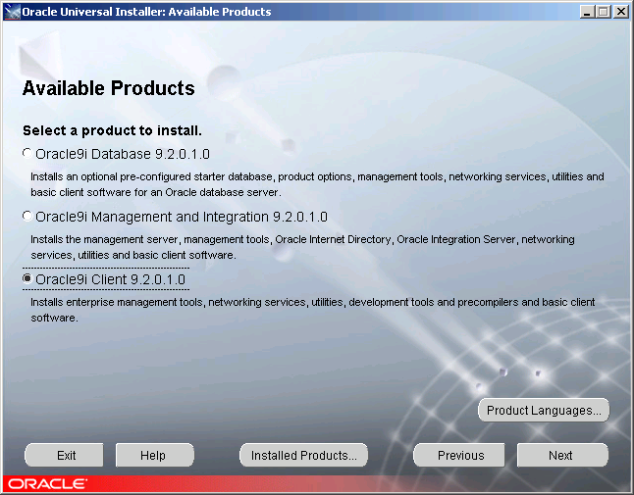

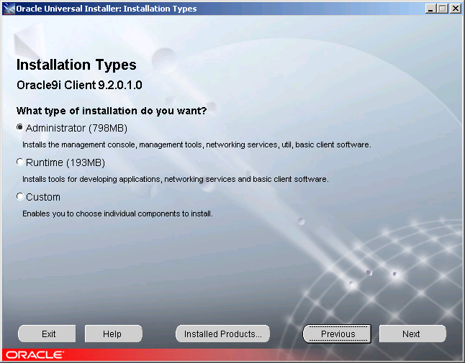

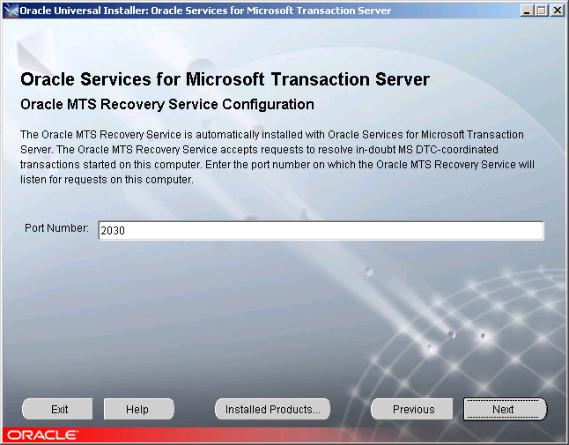

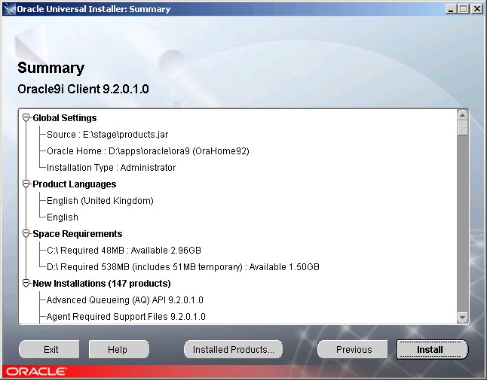

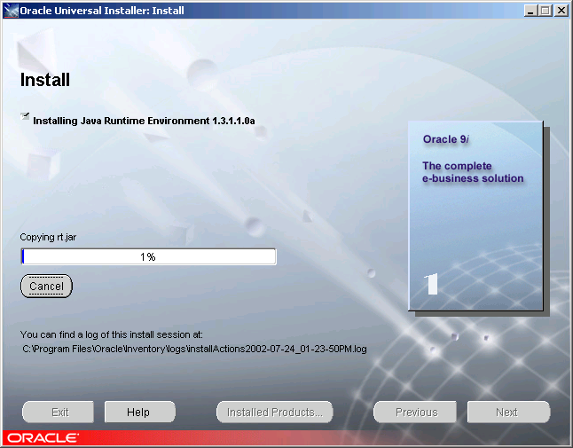

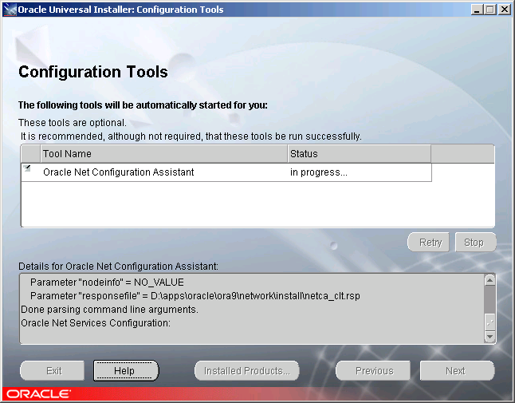

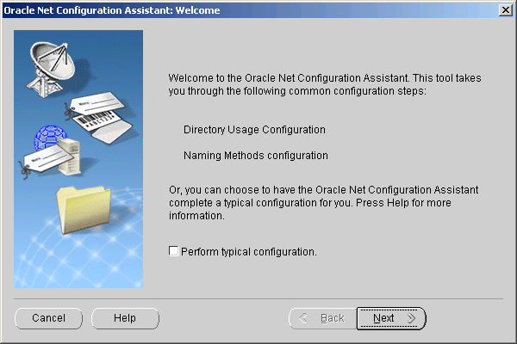

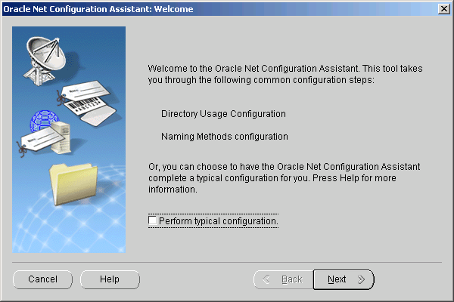

Click on “Cancel”

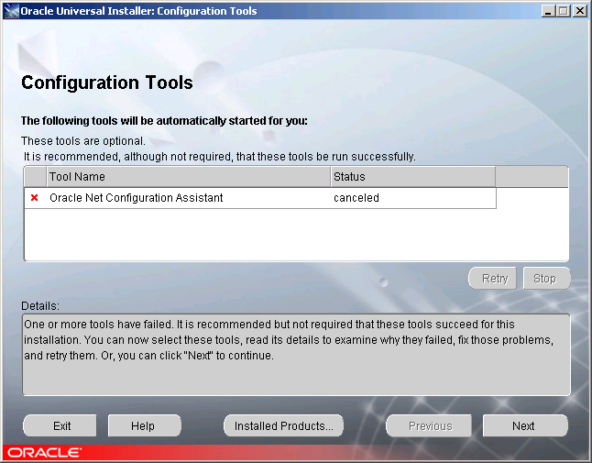

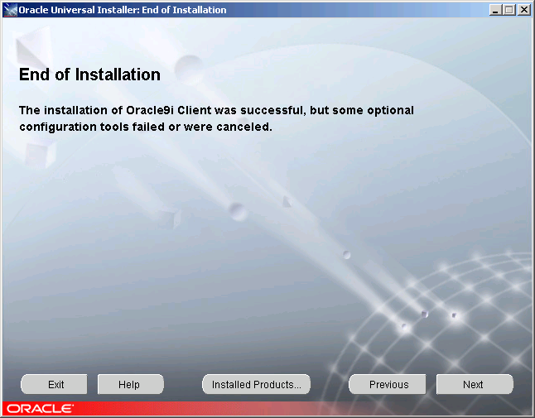

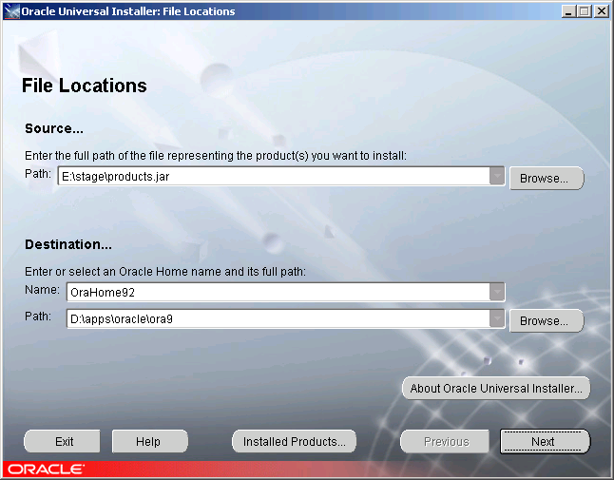

After completing the installation you will need to update the tnsnames.ora file which is located in D:\apps\oracle\ora92\network\admin\ if the installation instructions were followed.

TNSNAMES.ORA
The training scripts rely on the configuration info stored in \oracle\ora9\network\ADMIN\tnsnames.ora file. Below is an example of an entry.

CSDBPRD1 =
(DESCRIPTION =
(ADDRESS_LIST =
(ADDRESS = (PROTOCOL = TCP)(HOST = 10.31.67.20)(PORT = 1521))
)
(CONNECT_DATA =
(SERVICE_NAME = CSDBPRD1)
)
)

SYSTEM DSN

Create a System DSN (Data Source Name) called XHIBIT.

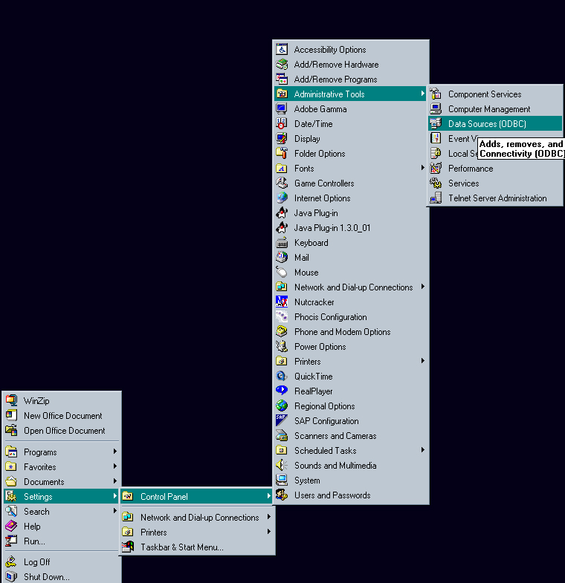
Firstly click on the System DSN tab as shown below.

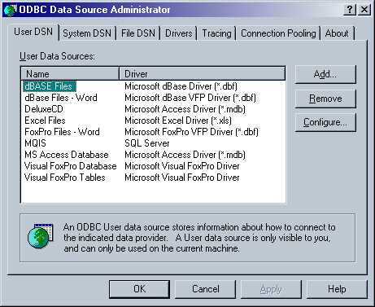

Then click on add.

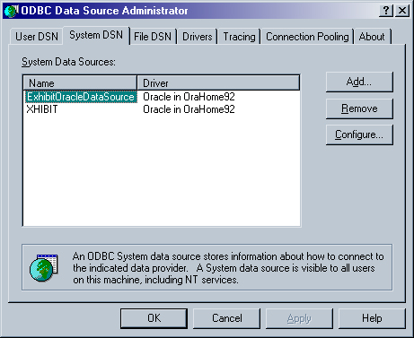

Scroll to the bottom of the list of drivers and select Oracle in OraHome92 before clicking on finish.

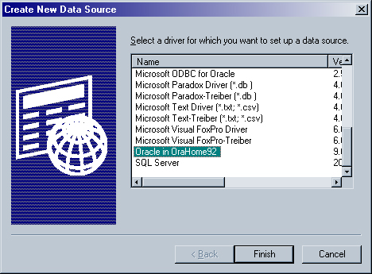

Enter XHIBIT as the Data Source Name (DSN).
The TNS Service Name will be the same as in the tnsnames.ora file.
The User ID has yet to be specified but is not necessary for the configuration of the DSN.

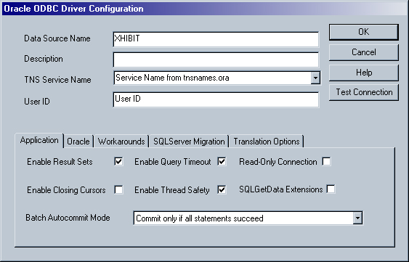

Finally you will be returned to the screen below and you should have an entry called XHIBIT as shown below.

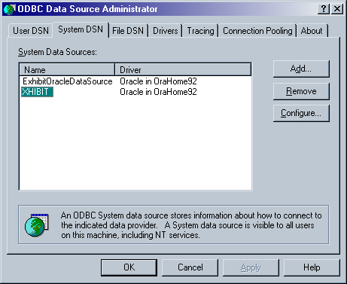

Training Application for running the scripts

Copy the attached file to any location on the Trainer’s machine.

To run the application simply double click on the file and specify a location to store the application. When the application has been installed simply double click on the file entitled Training.cmd to run the application.

